MicroHydroV1 — Go/No-Go Packet (ASAP Draft)
Executive Summary: This packet aggregates Stage B (bench) and Stage C (electrical/power) evidence for an expedited Go decision. Baseline tests are green per current samples; Stage B matrix and Stage C broadening are planned in the attached timeline.

1. Acceptance Criteria (Quick Reference)
Test | Requirement | Status (to-date)
T‑001 Jet Coherence | Coherence ≥ 0.90 | PASS on initial samples
T‑002 Tank Ripple | −30–50% vs straight inlet; no entrainment increase | PASS on initial samples
T‑003 Electrical Stability | Drift ≤ 0.1 Hz; no hunting | PASS on initial samples
T‑004 Power Output | 10–12 kW band | PASS on initial samples

2. Evidence Links & Plots
• Bench: ΔP–Q sweeps by vane angle & head — attach plots from RnD workbook/dashboard and intake CSVs
• T‑001: Coherence vs time (plots & raw) — attach plots from RnD workbook/dashboard and intake CSVs
• T‑002: Ripple reduction with baselines — attach plots from RnD workbook/dashboard and intake CSVs
• T‑003: Drift histograms & time series — attach plots from RnD workbook/dashboard and intake CSVs
• T‑004: Power vs time (10–12 kW band) — attach plots from RnD workbook/dashboard and intake CSVs

3. Risk Register Snapshot & Mitigations
Risk | Likelihood | Impact | Mitigation | Trigger
Clogging at nozzle throat | 2 | 3 | Debris screen; clean per run | Rising ΔP at constant Q
Cavitation at high Q | 2 | 4 | Maintain NPSHa ≥ 1 m; round edges | Noise/vibration onset
Leak at seals | 2 | 3 | Verify O‑ring compression; grease | Visible drips
Instrumentation drift | 2 | 3 | Zero transducers; two‑point check | Baseline shift

4. STW Decisions (Admit/Hold)
Item | Decision | Evidence Link
Hyperbolic Tank Inlet (diffuser) | Admit | Link to ΔP–Q & ripple results
9 mm pre‑swirl nozzle | Admit | Link to ΔP–Q & coherence results
DN125 penstock baseline | Admit | Bench config + stability notes
Conventional narrow ELC window | Admit | ELC drift plots
φ‑segmented penstocks | Hold | TBD: extended stability
φ‑ELC windows | Hold | TBD: hunting risk downselect
Hydram φ‑timing | Hold | TBD: flow ≥ +5% evidence

5. Decision
Recommendation: Provisional GO contingent on closing Stage B matrix and Stage C broadened stability. Final GO on completion of Week‑1/2/3 deliverables in the timeline.

6. Timeline (ASAP)
See attached Excel: MicroHydroV1_ASAP_Timeline.xlsx

Appendix — Auto‑Generated Plots

T‑001 — Jet Coherence vs Time
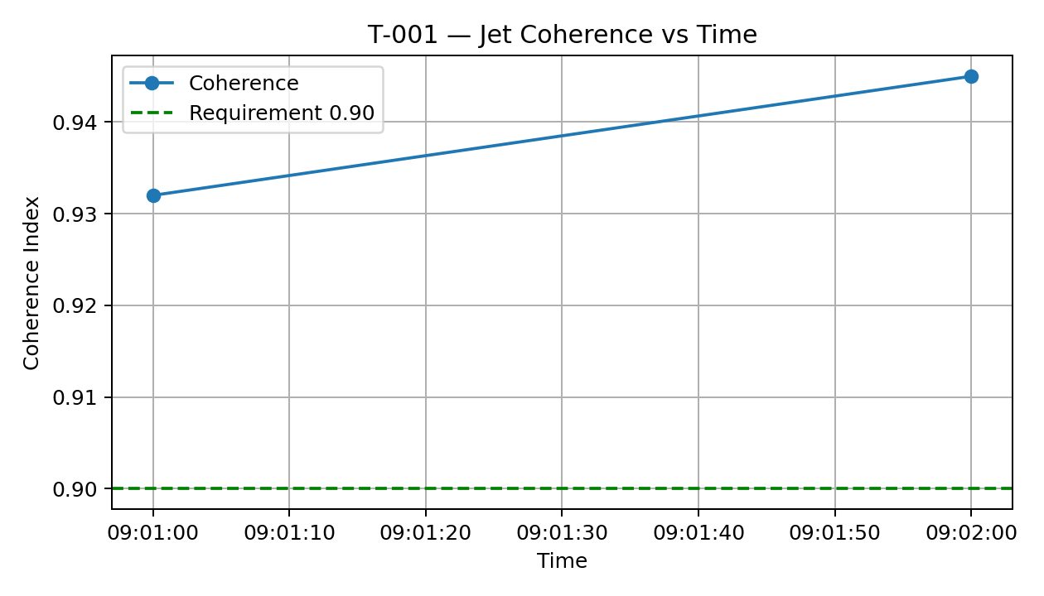

T‑002 — Tank Ripple vs Time
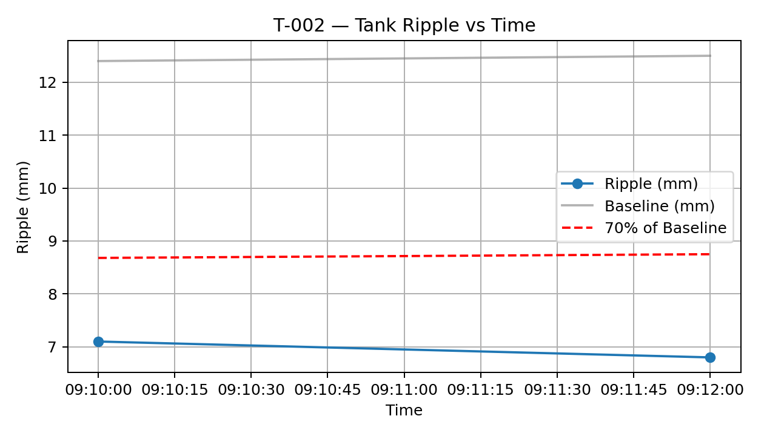

T‑003 — ELC Drift vs Time
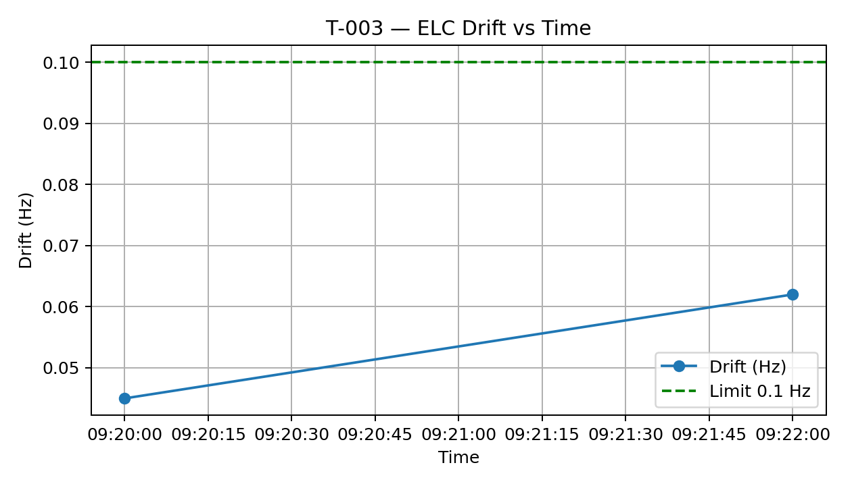

T‑004 — Power Output vs Time
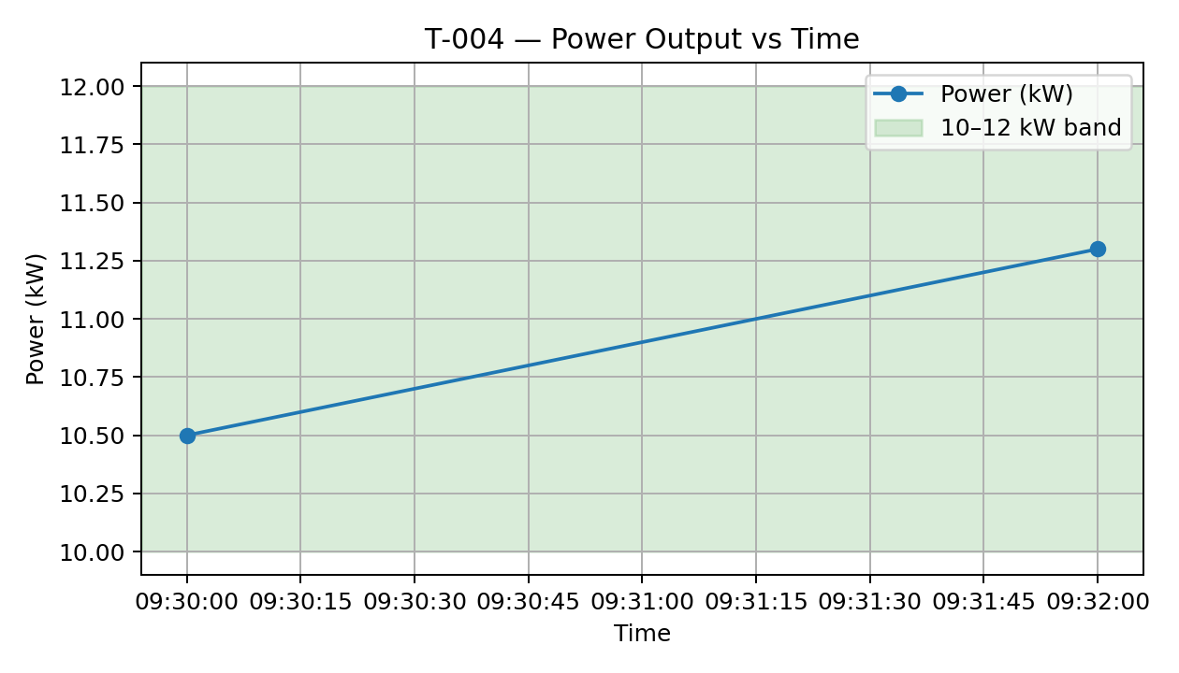

ΔP–Q by Vane Angle & Head
